Ancient Egypt Introduction Project
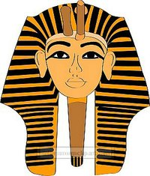
This term we will be exploring the Ancient Egyptians. As a starting point we would like your child to research one of the following aspects and create a Power Point presentation or fact file about their chosen theme.
- Pharaohs
- Tutankhamen
- Pyramids
- The River Nile
- Mummification
- Great Sphinx
- Ancient Egypt life

Presentations or fact files to be brought in on our Monday 11th January 2016 to share with the class that morning.
___________________________________________________
On Thursday 7th January Year 3 have an Ancient Egyptian workshop coming into school to give the children a taste of Cartouche art and Egyptian dance as an introduction to this term’s theme. Due to the expense of this enriching workshop, we ask for a voluntary contribution of £3 per child, so we are able to utilise our budget and provide further enriching opportunities for the children throughout the academic year. If your child is entitled to FSM , then this would be reduced to £1.50
Many thanks
Miss Ryan and Mr Hutchinson

